Astronomical Processing

Application Design Document

By: Starlight Incorporated

Contents

**1.** **Overview** 3

1.1 Summary 3

**2.** **Code and Mechanics** 3

2.1 Summary 3

2.2 Sprint 1 Functional Requirements 3

2.3 Sprint 2 Functional Requirements 3

2.4 Sprint 1 Non-Functional Requirements 3

2.5 Sprint 2 Non-Functional Requirements 4

2.6 Pseudocode 4

2.4.1 Sprint One 4

2.4.2 Sprint Two 4

**3.** **UI Design** 4

3.1 Layout Design 4

**4.** **Project Management** 5

4.1 Sprint One management 5

4.1.1 Project Tasks 5

4.2 Sprint Two management 5

4.2.1 Project Tasks 5

4.3 Final Sprint management 5

4.4 Meeting Minutes 5

Week 1 5

Week 2 5

Week 3 6

**5.** **Screenshots** 6

**6.** **References** 7

# **Overview**

## Summary

The task given for this project is to design a project using forms, that enters random integers into an array and has the ability to sort through, search through, and edit integers in the array.

During sprint two the program must now also perform several mathematical functions like calculate and display the range, average, mode, and the mid-range of the array. It must also have a second search function the goes through the array sequentially.

# **Code and Mechanics**

## Summary

The application must have the ability to sort numbers and search them via binary.

## Sprint 1 Functional Requirements

* Search / text box,
* Enter button for text box,
* Sort button,
* User feedback (displaying error and successful messages),
* Display array in a list box.

## Sprint 2 Functional Requirements

* A button to calculate the “mid-extreme”,
* A button to calculate the mode,
* A button to calculate the average,
* A button to calculate the range,
* A button to initiate a linear search,
* Tool tips on all buttons and boxes.

## Sprint 1 Non-Functional Requirements

* Application must have quick response times,
* We need to use Visual Studio and make the program as a Form,
* It needs to be available for approx. 100 users,
* The search needs to be a binary search,
* The sort needs to be a bubble sort.

## Sprint 2 Non-Functional Requirements

* We need to use Visual Studio and make the program as a Form,
* It needs to be available for approx. 100 users,
* All the code needs to execute within approx. 1 second of activation,
* The second search function needs to be a linear one consisting of 1 FOR loop and 1 IF statement,
* The mathematical calculations must be coded using custom algorithms,
* The GUI components must have detailed tool tips.

## Pseudocode

### 2.4.1 Sprint One

### 2.4.2 Sprint Two

# **UI Design**

## Layout Design

: UI Layout version 1.0. Made in Krita, to show basic understanding of how the app will be laid out

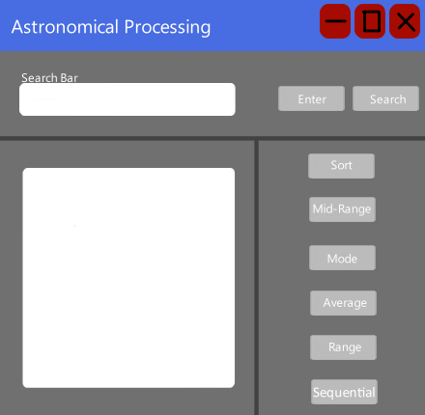

Version 1 of the layout, separates the app into 3 sections. The Search Bar with the search and enter buttons to be used with the bad. The Display box is singled out on it’s own, while the 6 buttons to the right of it is to be used with it.

The 6 buttons (Sort, Mid-Range, Mode, Average, Range and Sequential) are only able to be used with the display box, as they are all tied to that and not to the search bar.

NOTE: This version may vary come execution time to it.

# **Project Management**

## Sprint One management

This Sprint has Evan as the Scrum Master and Andrew as the other team member.

### Project Tasks

* The tasks we have been given and set for each other are:
* Make an array and set it to be sorted
* Display error and successful messages
* Bubble sort algorithm
* Binary search algorithm
* GUI (Buttons and search box)

## Sprint Two management

This Sprint has Andrew as the Scrum Master and Evan as the other team member.

### Project Tasks

* GUI
  + Mode button
  + Mid-Extreme Button
  + Average button
  + Range button
  + Detailed Tooltips
  + Sequential (Linear) Search button
  + Calculations

## Final Sprint management

## Meeting Minutes

### Week 1

We discussed the initial plans for the project and then decided who would be the scrum master for Sprint One. We discussed about who would do what task, as well as setting up Github and all the base plan work, as well as the forms project. Was an overall 40 min discussion.

### Week 2

This week, we discussed about what we have done and what we are doing for this week. Andrew talked about how they have made the array for our project, as well as making the UI buttons for it.

### Week 3

# **Screenshots**

1: Tasks set for sprint 1 - Week 1.

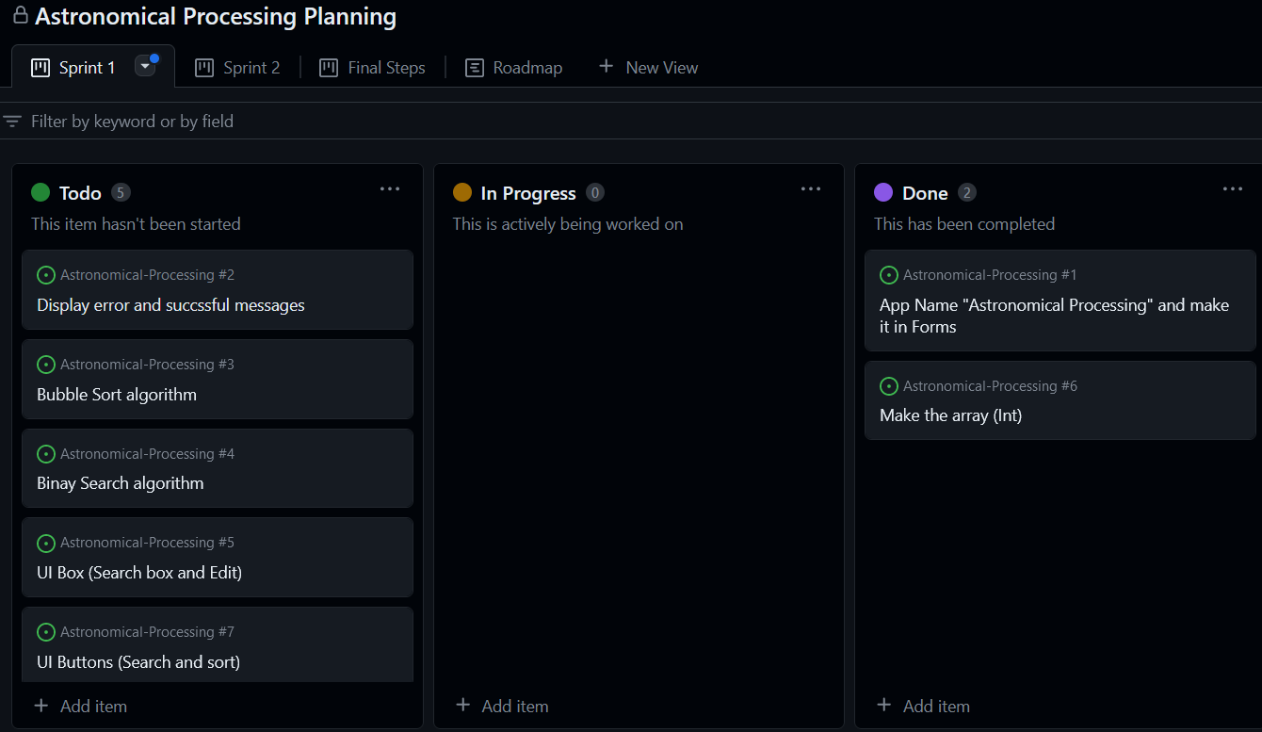

Sprint 1 GUI design

# **References**